Word Count:
Keywords: Mobile bar hire London, Mixologist hire London, Bar Hire London
Cocktail vs. Mocktail: Which One’s Right for Your Party?
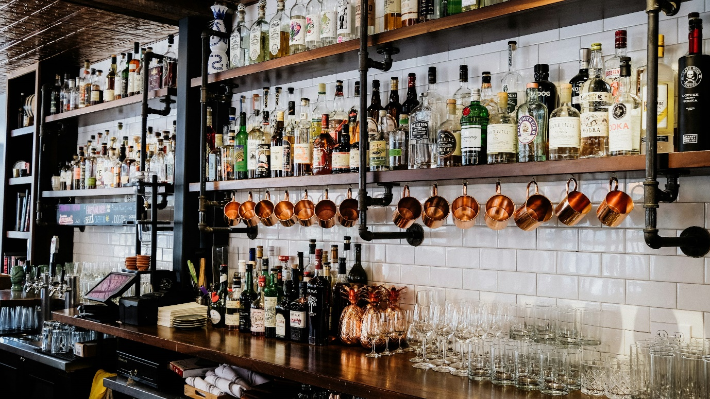
This image belongs to: David Straight
Alt text: Mobile bar hire London

When planning a memorable event in London, the question of cocktails versus mocktails is bound to come up. With the rise of mobile bar hire services and professional mixologists, it’s now easier than ever to cater to diverse tastes. But how do you decide between the sophistication of a perfectly crafted cocktail and the creativity of a non-alcoholic mocktail? Let’s explore the world of drinks and discover how mobile bar hire London services can help make your event in Canary Wharf, Mayfair, Chelsea, Knightsbridge, or Shoreditch unforgettable.

What Your Favourite Cocktail Says About You
Every cocktail tells a story, and your drink of choice can reveal a lot about your personality.

Martini Lover? You’re probably someone who appreciates sophistication and tradition.
Mojito Fan? You exude a fun-loving vibe and enjoy the zest of life.
Whiskey Sour Enthusiast? You value bold flavours and enjoy balancing strength with sweetness.

Now imagine your guests having personalized drinks prepared by a professional mixologist. With mixologist hire London, Ruby’s ensures each cocktail becomes a bespoke experience that reflects individual preferences.

Mobile Bars vs. Traditional Bars: Which One Wins?

Gone are the days of static bars being the only option. Mobile bars are revolutionizing events across London, offering flexibility, style, and convenience. Here’s how mobile bars outshine traditional setups:

Flexibility: Whether your venue is in Shoreditch or Knightsbridge, mobile bars adapt to your space and theme.
Customization: Choose from classic cocktails, modern mocktails, or a mix of both, tailored to your event.
Interactive Experience: Guests can watch skilled mixologists create drinks live, adding a touch of excitement.
With Mobile bar hire London, you’re not just serving drinks; you’re creating an experience.

Exploring the Best Mobile Cocktail Bar Services in London
In a city as dynamic as London, the demand for exceptional mobile bar services is high. Ruby’s stands out by bringing creativity, elegance, and professionalism to every event. Whether you’re hosting in Mayfair, Chelsea, or Canary Wharf, Ruby’s mobile cocktail bar adds a unique charm to any gathering.

Our services include:

Personalized Menus: Tailor your drink options to match your event’s theme.
Expert Mixologists: Our skilled professionals craft cocktails and mocktails that impress even the most discerning palates.
Seamless Setup: From small spaces in Chelsea to grand halls in Knightsbridge, our bars fit perfectly.

Winter Weddings in London: Warm Up with a Mobile Bar
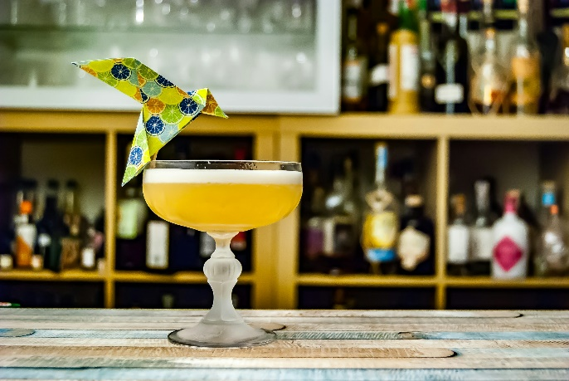
This image belongs to: Johann Trasch
Alt text: Mixologist hire London

Winter weddings have their own charm, but they also call for thoughtful planning to ensure guests stay cozy and entertained. Ruby’s mobile bar offers seasonal delights perfect for a London winter:

Warm Cocktails: Mulled wine, hot toddies, or spiced apple martinis bring warmth to the festivities.
Stylish Mocktails: Non-drinkers can enjoy options like cinnamon-infused apple cider or spiced cranberry fizz.
Elegant Presentation: From sleek setups in Mayfair to rustic designs in Shoreditch, our bars adapt to your vision.
Hiring a mobile bar adds both warmth and sophistication, making your winter wedding truly magical.

Top 5 Reasons to Hire a Mobile Bar in London for Your Next Event
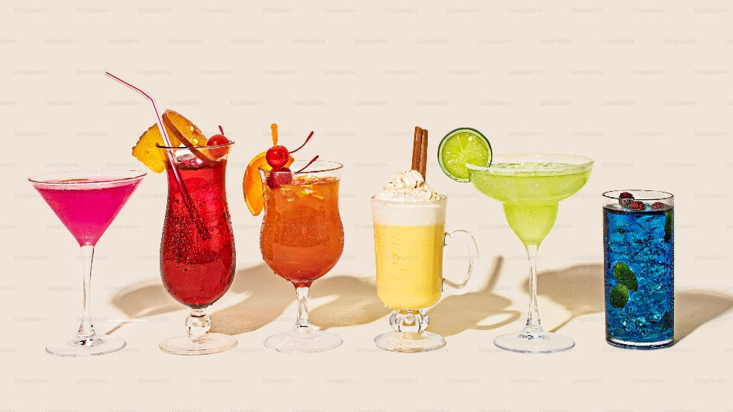
This image belongs to: Shamblen Studios
Alt text: Bar Hire London

If you’re still wondering whether a mobile bar is right for your event, here are five reasons why it’s the perfect choice:

Convenience: From set-up to clean-up, a mobile bar handles it all, leaving you free to enjoy your event.
Customization: Choose drinks, décor, and service styles that reflect your personal taste.
Entertainment: Watching a skilled mixologist in action adds excitement and intrigue.
Versatility: Whether it’s a wedding in Knightsbridge or a corporate event in Canary Wharf, mobile bars fit any occasion.
Unforgettable Experience: Guests will talk about the unique drinks and atmosphere long after the event ends.

Frequently Asked Questions

1. What areas in London do you serve?
We provide mobile bar services in Canary Wharf, Mayfair, Chelsea, Knightsbridge, Shoreditch, and beyond.

2. Do you offer non-alcoholic options?
Yes, we specialize in mocktails alongside our cocktail offerings to ensure all guests are catered to.

3. How far in advance should I book a mobile bar?
We recommend booking at least 3-6 months in advance, especially for weddings and large events.

4. Can I customize the drinks menu?
Absolutely! Our team works with you to create a menu that reflects your preferences and event theme.

5. What makes Ruby’s stand out from other mobile bar services?
Ruby’s combines professional service, creative presentation, and personalized options, ensuring your event is exceptional.

Let’s Make Your Event Unforgettable!
Whether you’re planning a chic wedding in Mayfair, a corporate gathering in Canary Wharf, or a festive party in Chelsea, Ruby’s mobile bar service is here to elevate your event. With expert mixologist hire London and seamless bar hire London, we guarantee an experience that your guests will rave about.

Contact us today to explore our Mobile bar hire London packages and start planning the perfect drinks menu for your event. Let’s toast to creating unforgettable memories in the heart of London!

